**Huffman Based LZW Lossless Image Compression Using Retinex Algorithm**

In this paper author is describing concept to compress images using 3 different algorithms such as Huffman Coding, LZW lossless Coding and Retinex Algorithm.

1. Huffman Compression: First this algorithm will apply on input image which will extract code from images in the form of pixels and then remove redundant (duplicates) and irrelevant pixels from image and build a dictionary table.
2. LZW lossless Algorithm: This algorithm will take Huffman dictionary from input and then compress image without losing quality of the image. This means it will extract only important pixels from Huffman dictionary and ignore redundant and irrelevant pixels.
3. Retinex Algorithm: This is an image processing algorithm which will correct dull or blur colours pixels to remove noise and give some neatness to the image.

If u read entire paper author is describing above 3 points only to compress and provide quality to the images.

You can put all samples text files inside ‘TextFiles’ folder and all sample images inside ‘ImageFiles’ folder. From two folders you can upload appropriate files and perform compression.

Screen shots

To run this project double click ‘run.bat’ file to get below screen

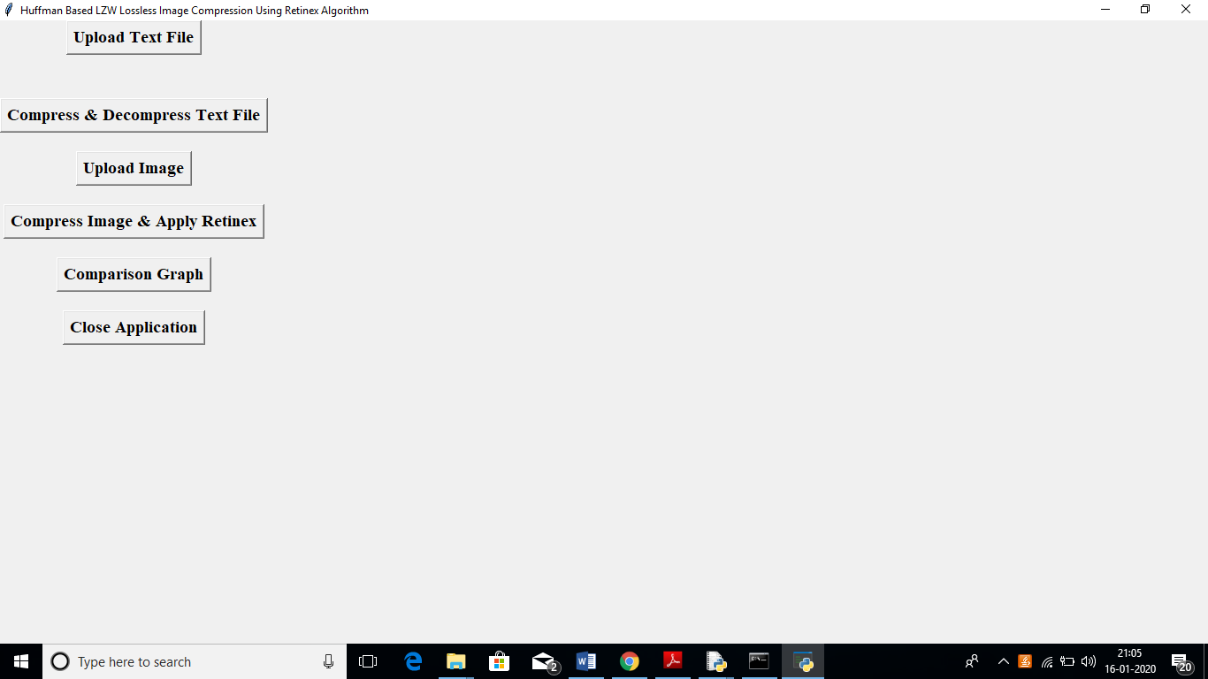

In above screen if you want to compress text file then click on ‘Upload Text File’ button and upload text files.

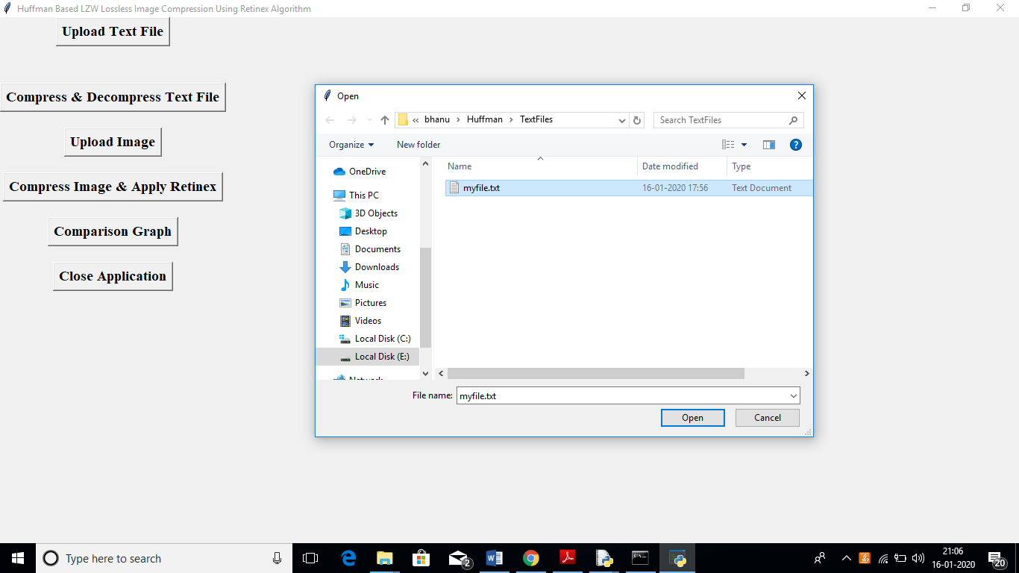

In above screen I am uploading ‘myfile.txt’ file and after upload will get below screen

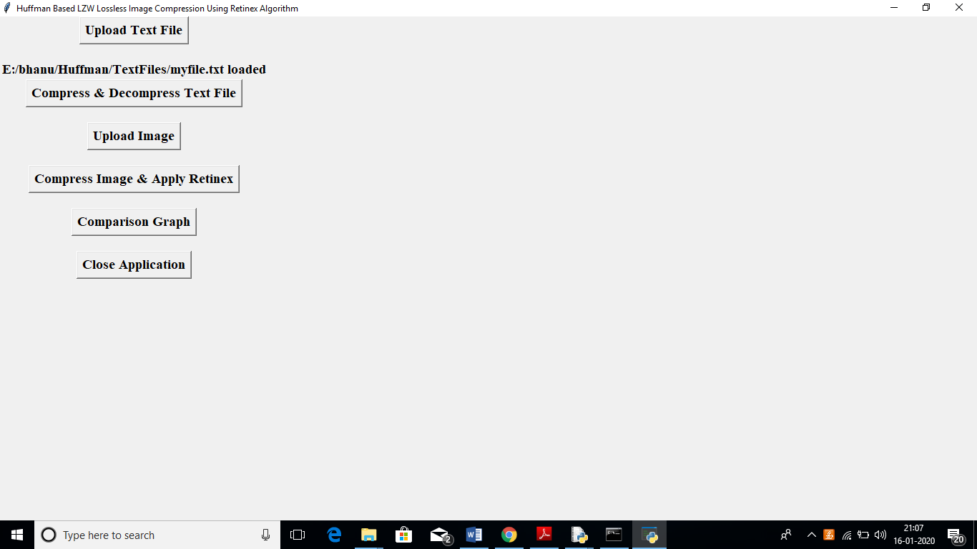

Now click on ‘Compress & Decompress Text File’ button to get compress and decompress text file.

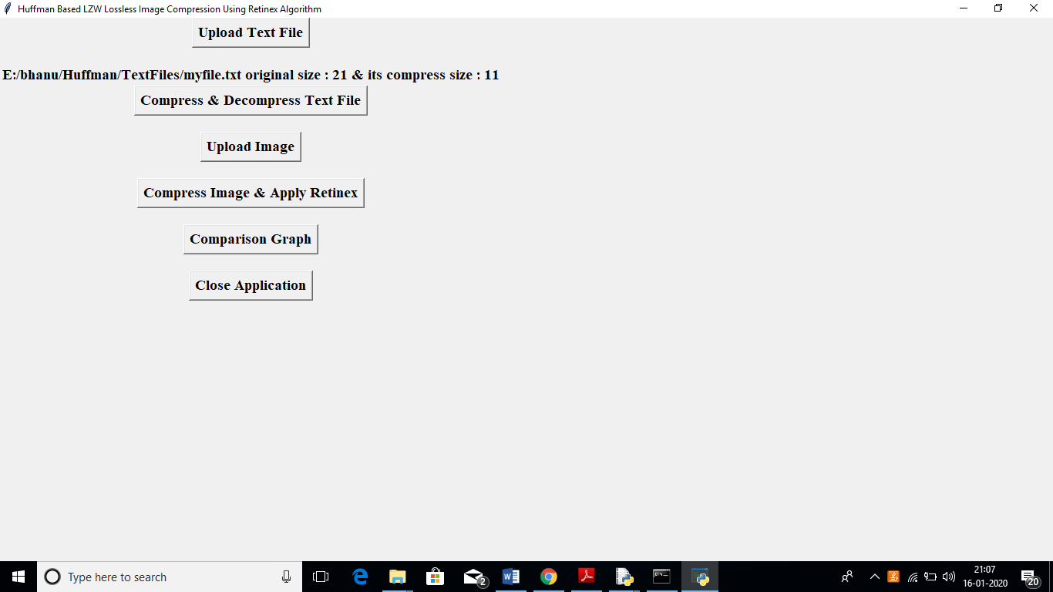

In above screen we can see message as original file size is 21 Bytes and after compress file size is 11 Bytes. Now you can see original file size inside ‘TextFiles’ folder

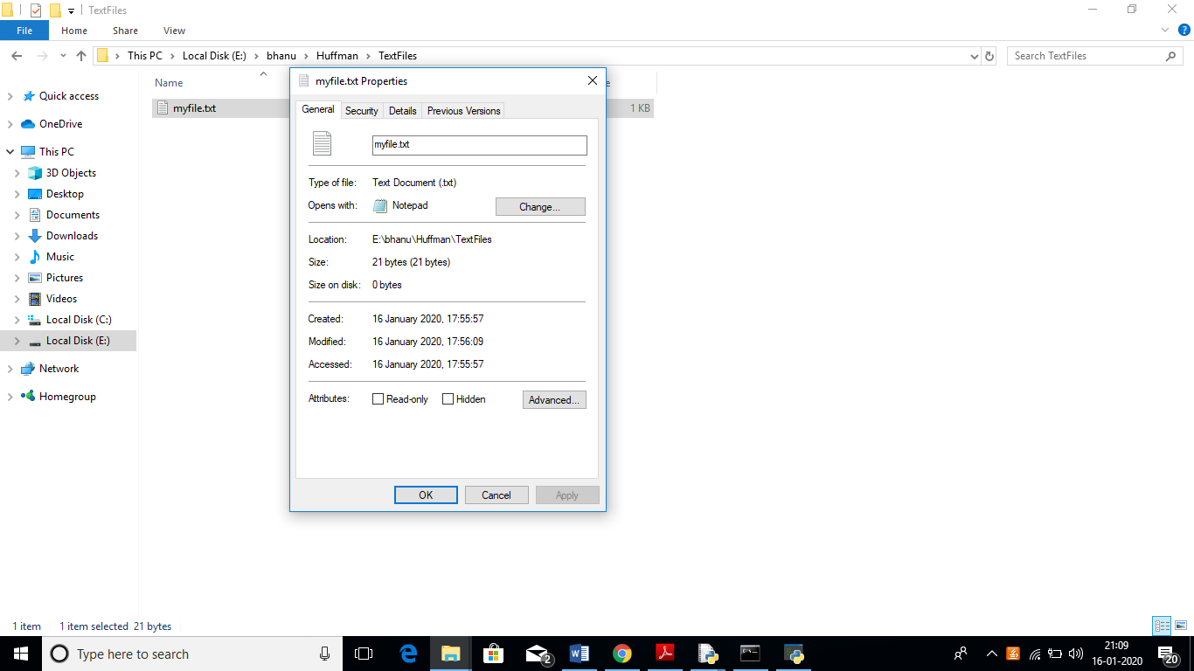

In above screen we can see original file size in directory also, now see compress file size inside ‘compress’ folder

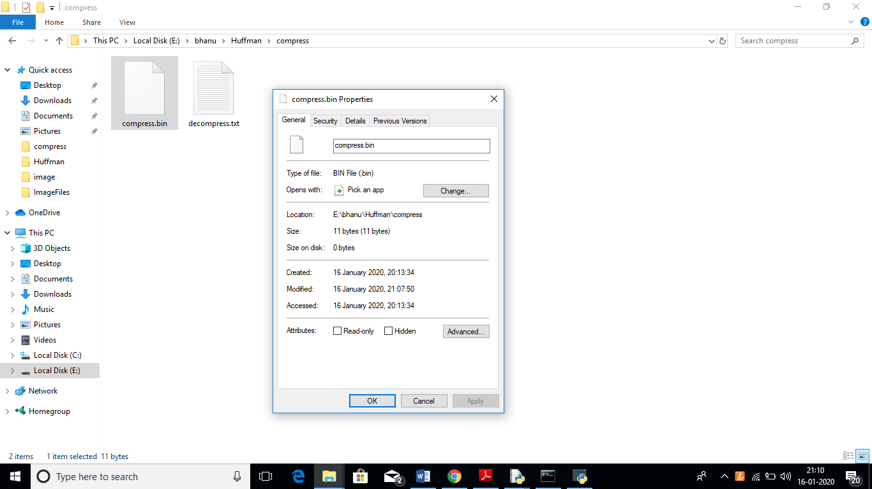

In above screen compress.bin files size is 11 Bytes and decompress file contains decompress data. Similarly click on ‘Upload Image’ button to upload image

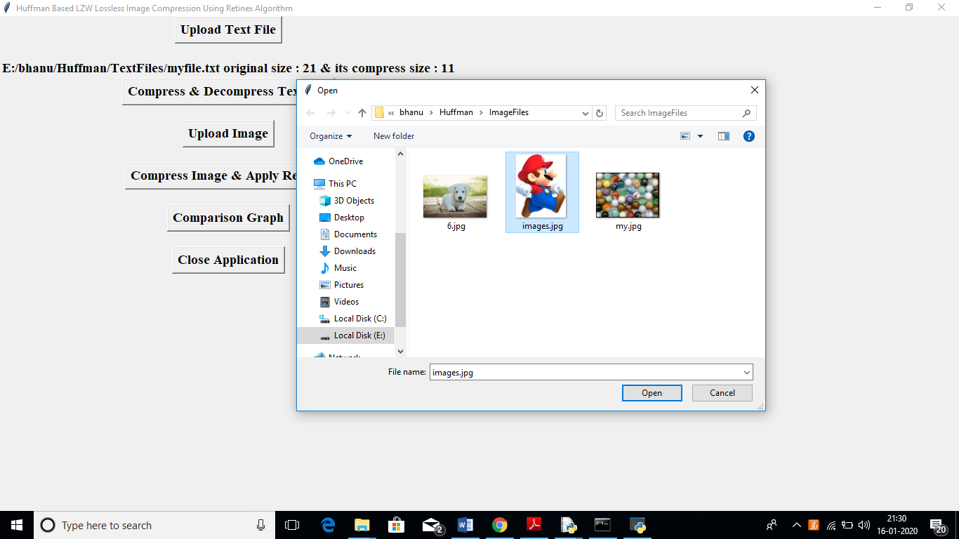

In above screen uploading ‘images.jpg’ file and after uploading image will get below screen

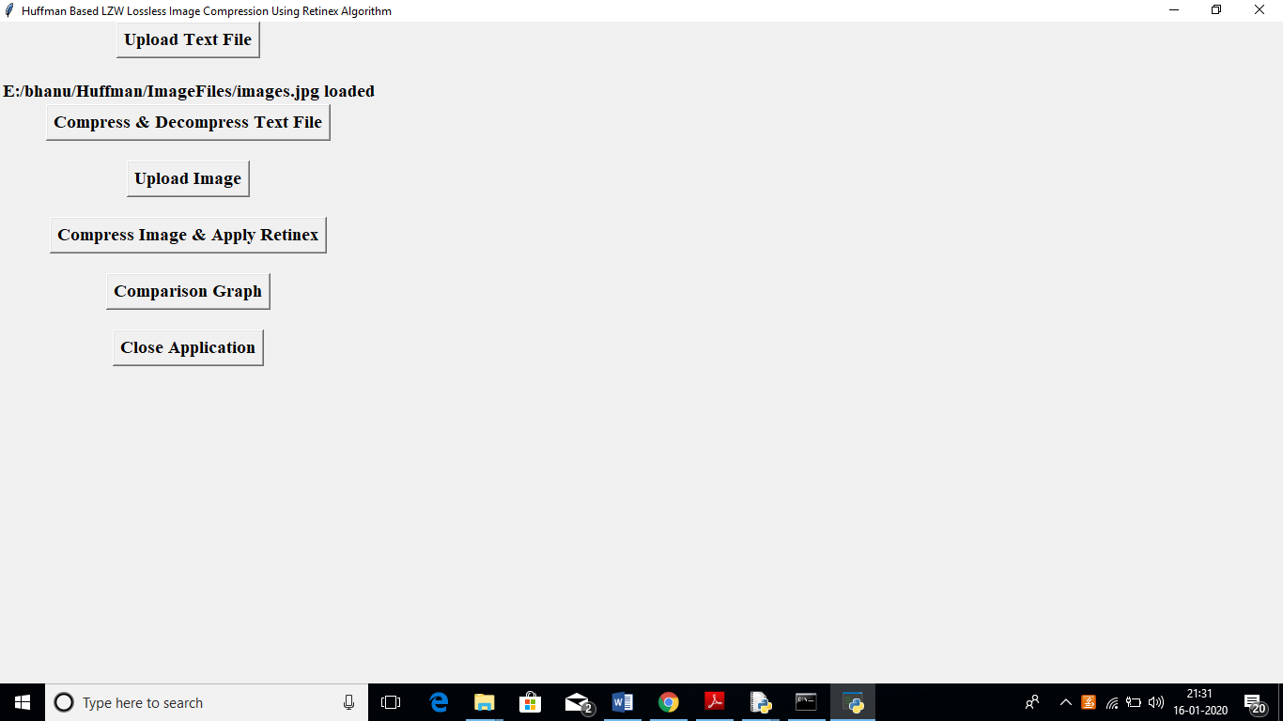

Now click on ‘Compress Image & Apply Retinex’ button to compress image

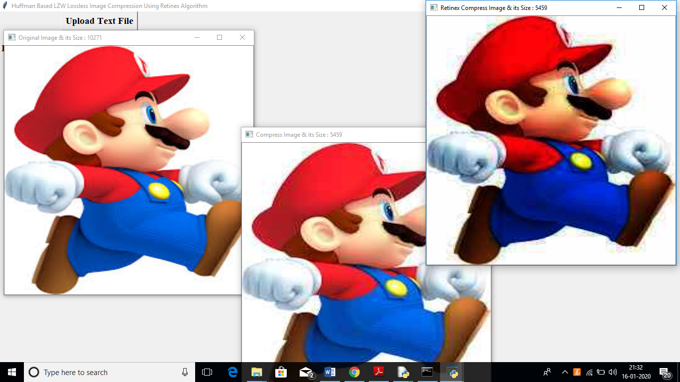

In above screen first image is the original image and you can see its name and size in title bar of the image, first image is the original image and its size is 10271 bytes and second image is the compress image and its size also u can see in title bar and compress image size is 5459 bytes and third image is Retinex algorithm applied compress image and its size also same and you can see after applying Retinex algorithm third image is looking little clean and bright. Now click on ‘Comparison Graph’ button to get below graph

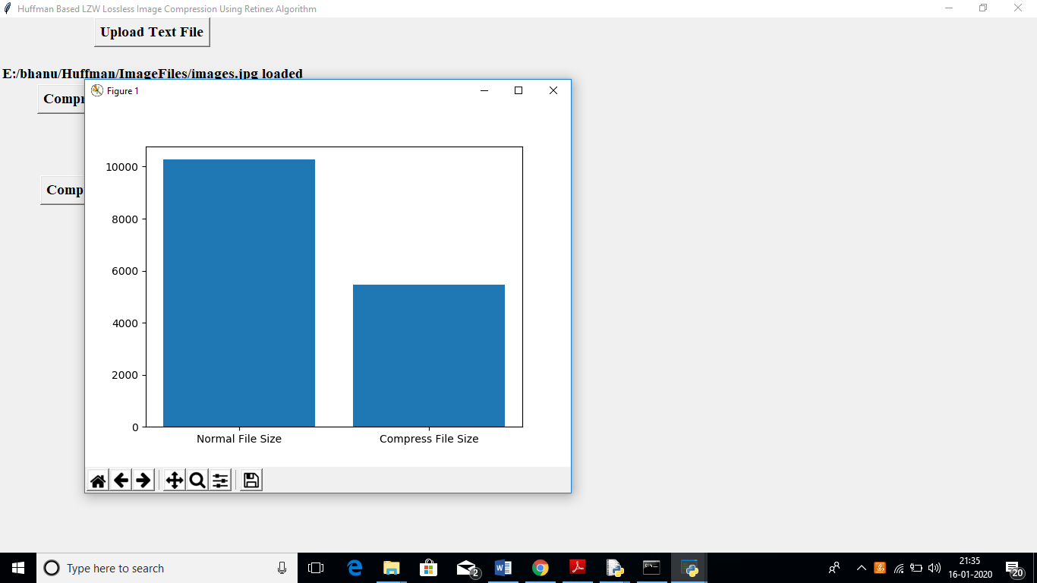

In above graph x-axis represents normal and compress image and y-axis represents its size. Above graph clearly shows after applying compression we can reduce image size memory. Now you can see image size in directory

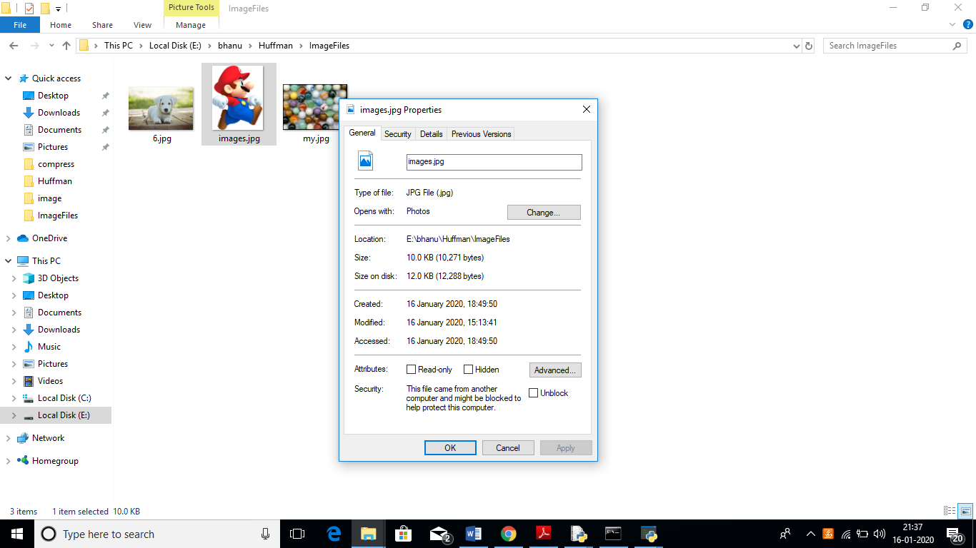

In above screen original images.jpg file size is 10KB and now see compress file size in compress folder

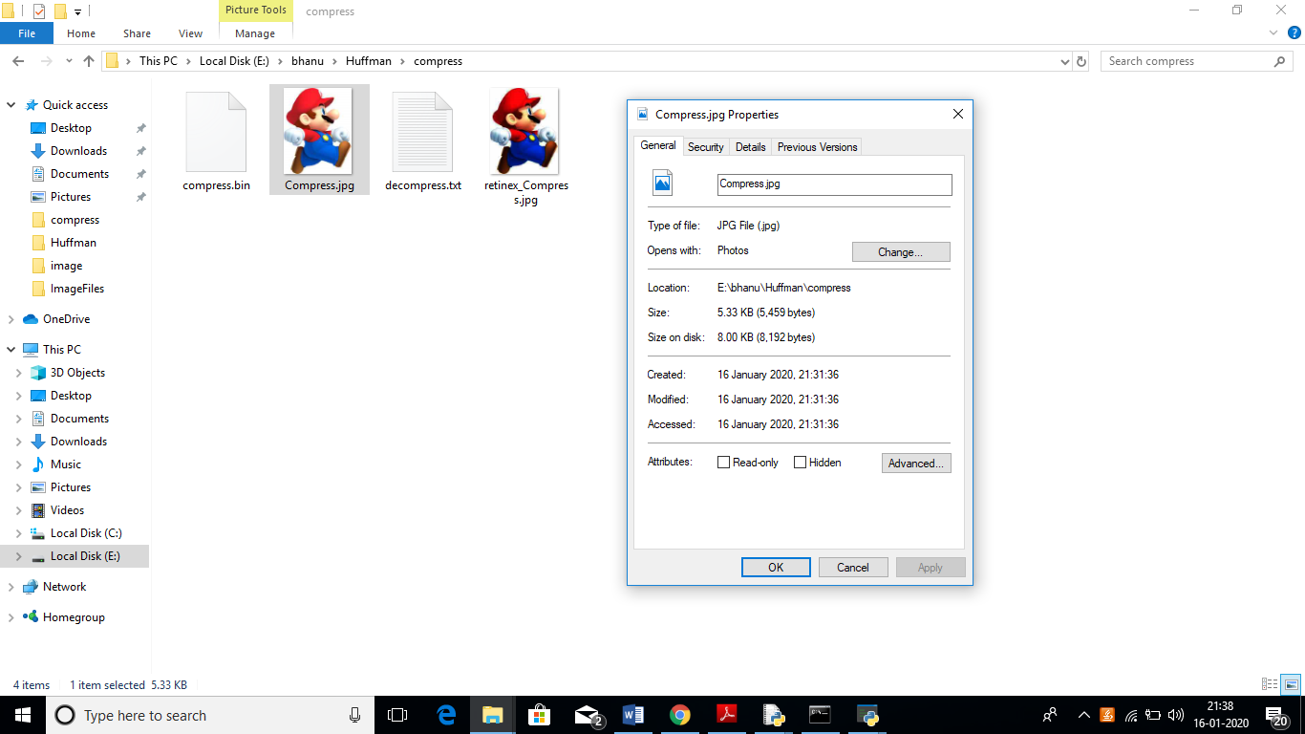

In above screen compress.jpg file size is 5.33 KB and we can see Retinex applied image also along with compress image